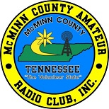
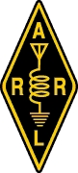

Official ARRL Hamfest Sponsored by The McMinn County Amateur Radio Club
WHEN: July 16th, 2022, 7:00 am - ?
WHERE: McMinn County Expo Center
Located in the Athens Regional Park, Athens, TN
(approximately 1 mile off I-75, Athens exit 49)
WHAT: Amateur Radio Vendor & Trader’s Fest
TALK–IN: 147.060 (-) 141.3 {Alt. 146.490 Simplex} APRS Object
Bigger and Better

UNDER ROOF SPACES $10 EACH / OUTDOOR TAILGATE SPACES $5 EACH!
DEALERS MAY ARRIVE AT 5PM FRIDAY TO SET UP! (Call for info)
ALL SETUPS MUST ADHERE TO THE MCARC HAMFEST POLICIES AS POSTED ON THE McMINN ARC WEBSITE
DOOR PRIZES! – AS ALWAYS, LOTS OF GREAT DOOR PRIZES.
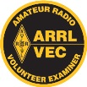
FOLLOW US FOR DETAILS
Amateur License Testing On-site
GENERAL ADMISSION $5 (Which includes one door prize ticket)

CAMPING, MOTELS, RESTAURANTS, ATTRACTIONS, STORES NEARBY
On-site Breakfast & Lunch available

FOR INFORMATION OR TO RESERVE A SPACE
CONTACT: (423) 368-1473 / KC4JIY@yahoo.com -or- Visit www.mcminnarc.com

